Assignment - 4

|  |  |
| --- | --- |
| **Student Name/ID Number:** | Francis Roel L. Abarca - bdse-0922-113 |
| **Academic Year:** | 2022-2023 |
| **Module Name:** | Front End Web Development |
| **Project Title:** | Single Page Application |
| **Submission Date:** | November 23, 2022 |



Date:

Student signature:

I certify that the work submitted for this assignment is my own and research sources are fully acknowledged.

**Learner declaration**

Screenshots

Home Page

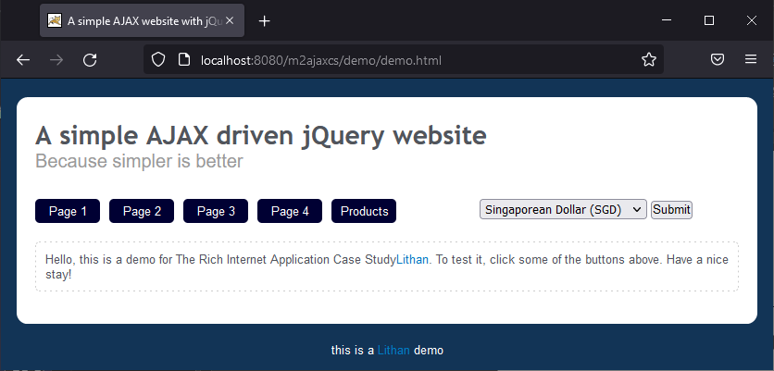

Page 1

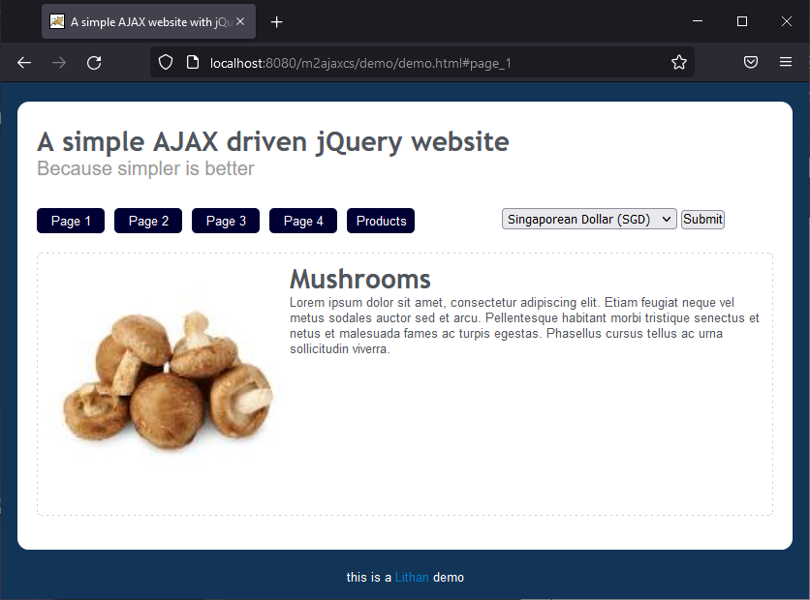

Page 2

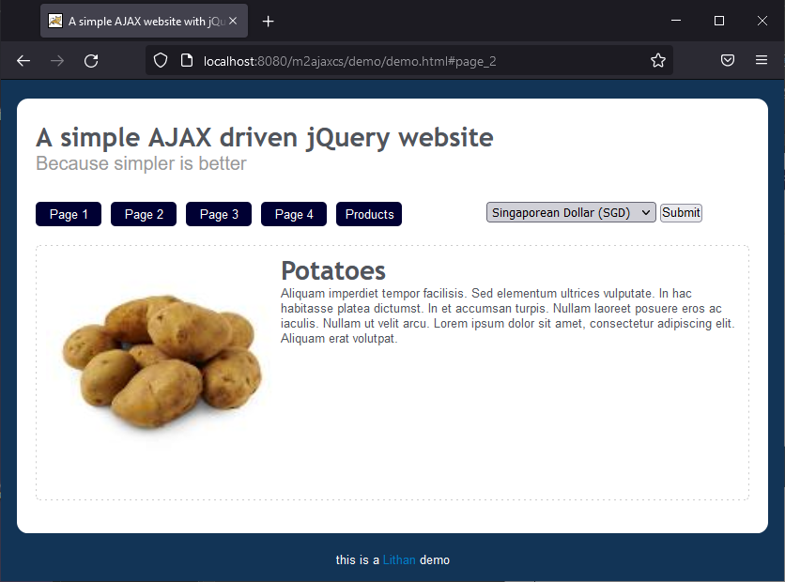

Page 3

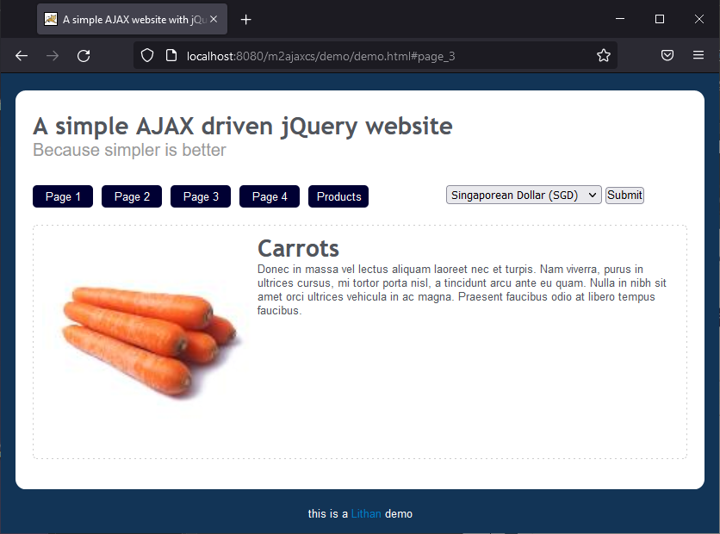

Page 4

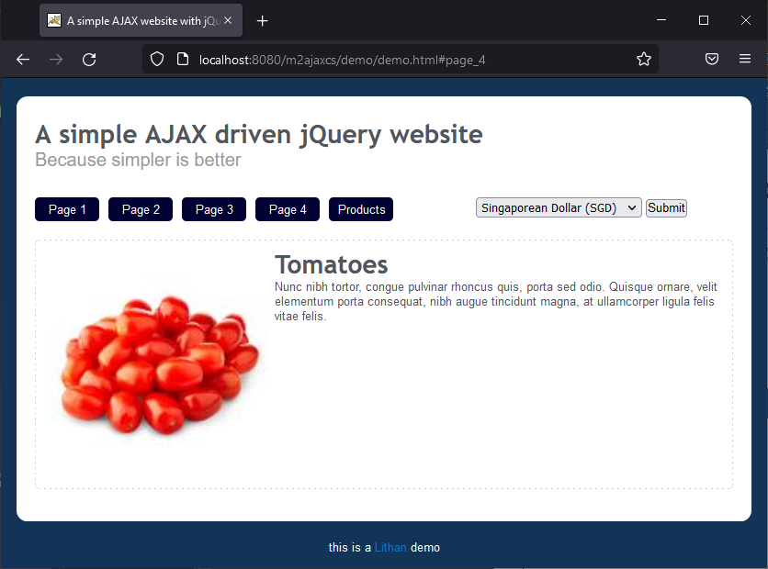

Products & Currency Change

SGD

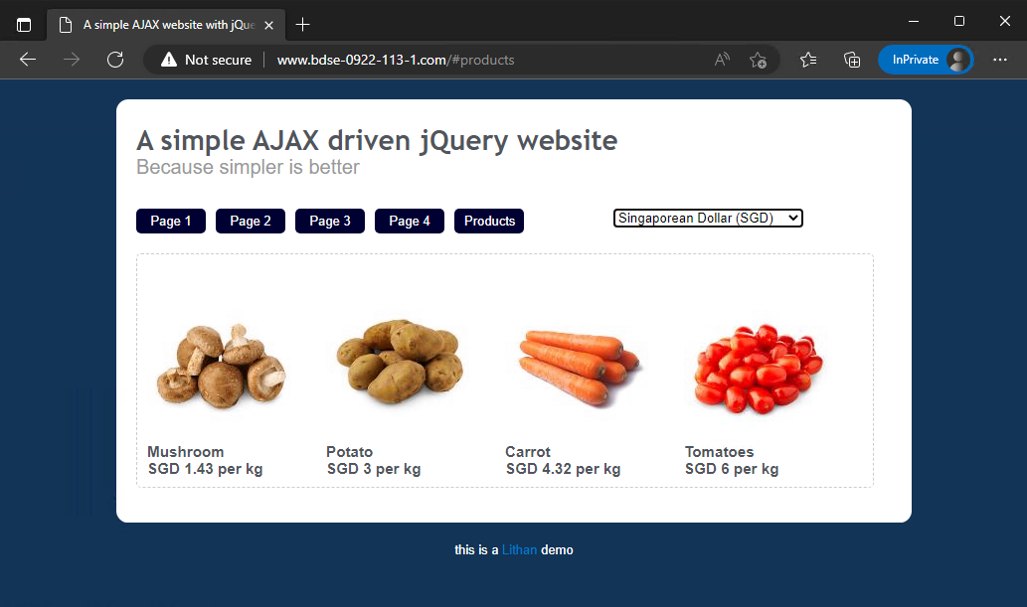

PHP

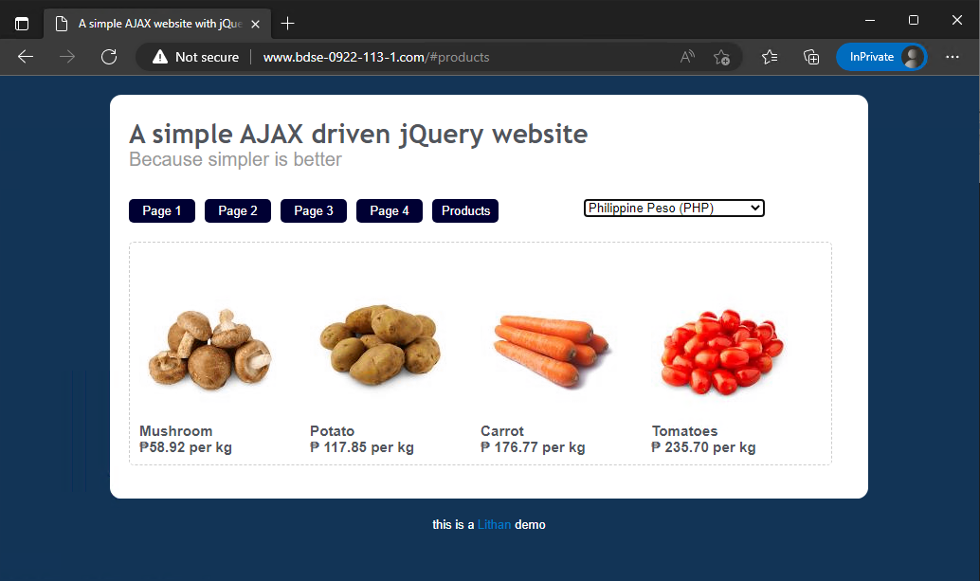

USD

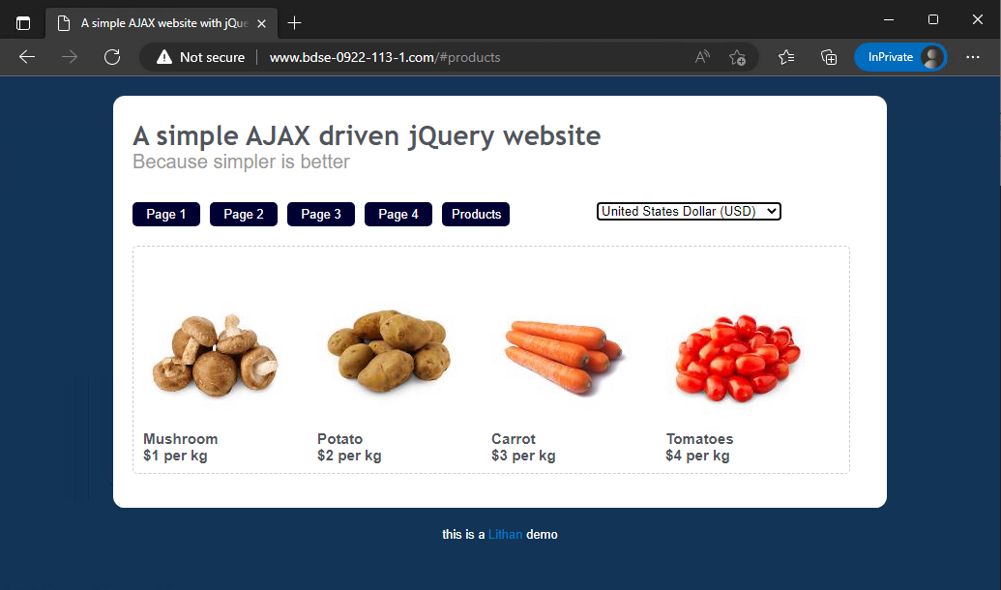

Back End (apache2)

Virtual Host working (bdse-0922-113-1.com)

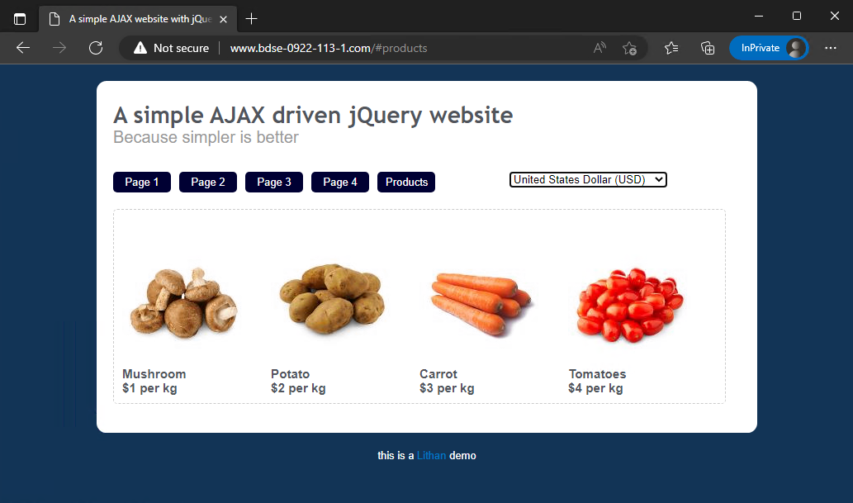

Virtual Host working (bdse-0922-113-2.com)

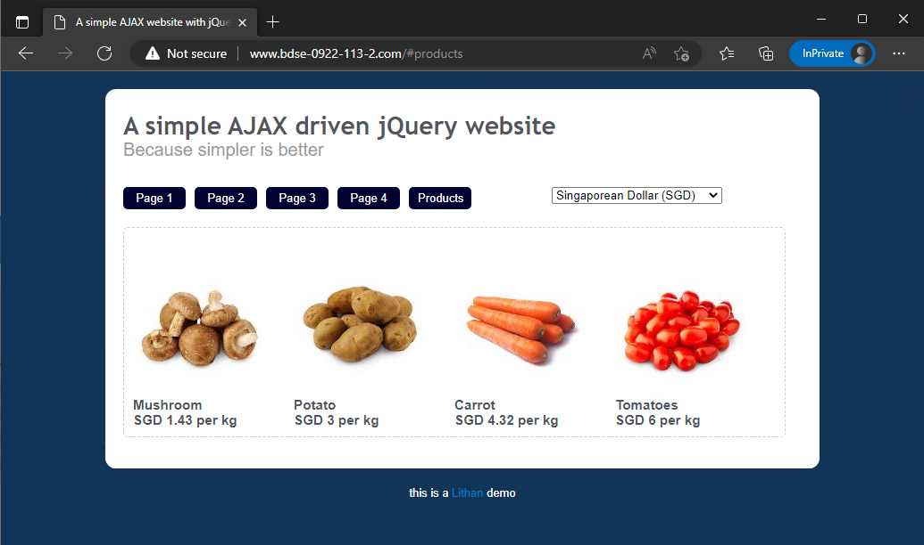

A screenshot of the httpd-vhosts.conf (Line 44 to Line 70) inside C:\Apache24\conf\extra

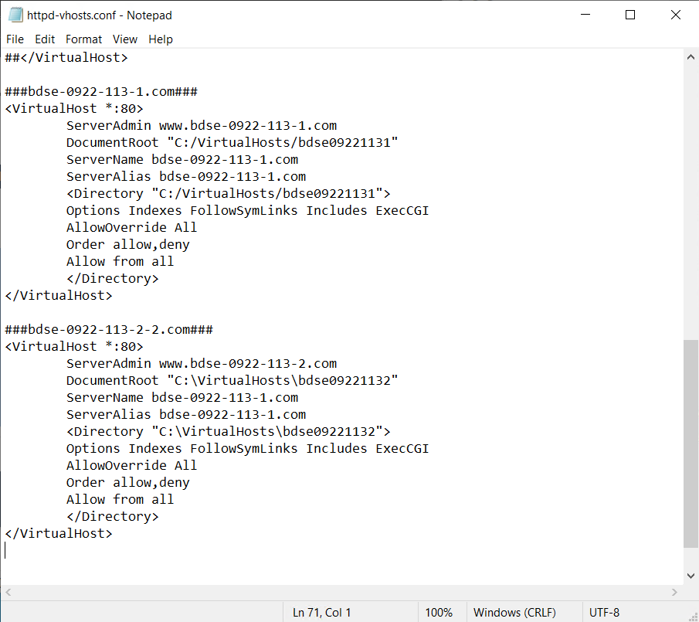

A screenshot of the hosts file from C:\Windows\System32\drivers\etc

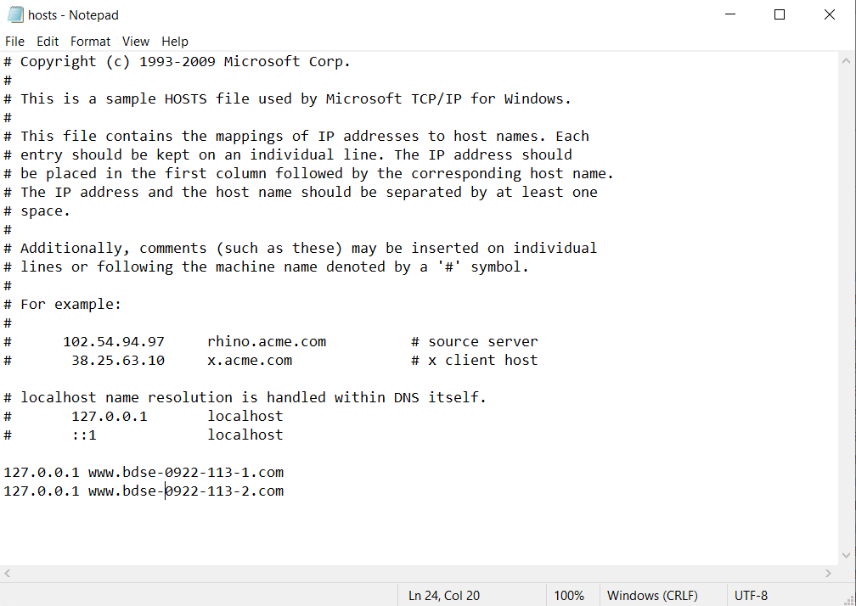

A screenshot of both the .htaccess and .htpasswd files inside \bdse-0922-113-1.com  
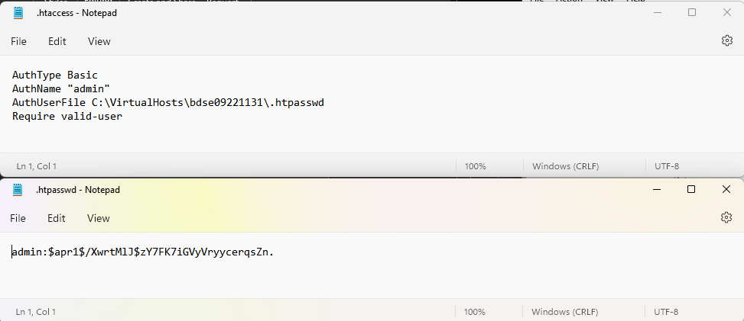

Note: I had to modify the demo.html from the source code files to index.html because by default, Apache looks for the index.html of the root website directory.